|  |
| --- |
| Asia_Pacific_College_Logo.png  b2c_logo_100e1.jpg |
| Resources for the Blind – Inventory System |
| Software Quality Assurance Plan |
|  |
| **Clarence Carillaga**  **Pauline Gabrielle De Ocampo**  **Phil Harvey Burgos** |
| **March 2015** |

Table of Contents

[Project Team 3](#_Toc416095222)

[Software Project Management Plan 3](#_Toc416095223)

[Vision and Scope 3](#_Toc416095224)

[Feasibility and Risk Analysis 4](#_Toc416095225)

[Management Approach 5](#_Toc416095226)

[Technical Approach 6](#_Toc416095227)

[Requirements Document 9](#_Toc416095228)

[The Logical Database Description (LDD) 9](#_Toc416095229)

[The Requirements Document (SRD) 10](#_Toc416095230)

[The Requirements Traceability Matrix (RTM) 10](#_Toc416095231)

[Design Document 11](#_Toc416095232)

[The Physical Database Description 11](#_Toc416095233)

[The Software Design Document 12](#_Toc416095234)

[Online Help 17](#_Toc416095235)

[Data Areas 17](#_Toc416095236)

[Optional Scenarios 18](#_Toc416095237)

[Data Dictionary 19](#_Toc416095238)

[Implementation Map 20](#_Toc416095239)

[The Implementation Map 20](#_Toc416095240)

[Test Plan 21](#_Toc416095241)

[The Test Plan 21](#_Toc416095242)

[Deployment Plan 22](#_Toc416095243)

[Acceptance Plan 22](#_Toc416095244)

[Installation & Acceptance 23](#_Toc416095245)

[The Acceptance Configuration Plan 23](#_Toc416095246)

[References (Hyperlinks) 24](#_Toc416095247)

# Project Team

|  |  |
| --- | --- |
| Name | Email |
| Clarence Carillaga | cccarillaga@student.apc.edu.ph |
| Pauline Gabrielle De Ocampo | aideocampo@student.apc.edu.ph |
| Phil Harvey Burgos | pdburgos@student.apc.edu.ph |

|  |  |  |
| --- | --- | --- |
| Name | Position | Email |
| Mr. Allan Cotecson | Professor | allanc@apc.edu.ph |

# Software Project Management Plan

## Vision and Scope

**Vision**  
To be able to create an Inventory System that will monitor Resources For The Blind's daily transactions and provide a friendly interface for both sighted and visually-impaired.  
  
**Scope**  
Expected functions of the system:

*Item Records*

* Shows items
* Shows the product information *(details about the product, such as, name, price, quantity, etc.)*
* User can add, modify and delete product information

*User Information*

* Show customer information *(personal details about the customer, such as, customer name, address, contact, etc.)*
* Show supplier information *(personal details about the supplier, such as, supplier name, address, contact, etc.)*
* The user can add, modify, and delete customer information
* The user can add, modify, and delete supplier information

*Order Records*

* Show order to suppliers information *(item name, quantity ordered, etc.)*
* The admin can add, modify, and delete order information
* Generate a report based on annual orders

*Purchase Records*

* Show customers' purchases information *(item name, amount, quantity ordered, etc.)*
* The admin can add, modify, and delete order information
* Generate a report based on the annual transactions

The system will be both sighted and visually-impaired friendly. For the visually-impaired aspect, its interface will be manipulated by controls that will mostly be composed of tab keys, arrow keys and buttons with labels.

## Feasibility and Risk Analysis

|  |  |  |
| --- | --- | --- |
| Feasibility Factor | Risk | Team Resolutions |
| Technological and System Feasibility | * Absence / Availability of tools * Competence of the team | * The team will be using an open-source framework: Yii. To be more knowledgeable, there are also available manuals regarding it. For the hardware, members have desktops and laptops for development, and smart phones which are ready to use for android. * The team will be using their learning prowess with regard to programming (PHP) and other skills they acquired from their PBL subjects. |
| Economic Feasibility | * Cost of tools to be used | * The team will be using an open-sourced framework and their own hardware devices. |
| Operational Feasibility | * End-users acceptance of the system | * The team will make sure that the system will conform to the requirements of client; necessary documentation will be required. |
| Schedule Feasibility | * Short project duration | * The team will follow a schedule in order to fulfill all requirements gathering, development and testing tasks within 10 weeks. |

## Management Approach

The development methodology to be used for the project is the *Agile Method*, in which series of testing will transpire as the development progress.

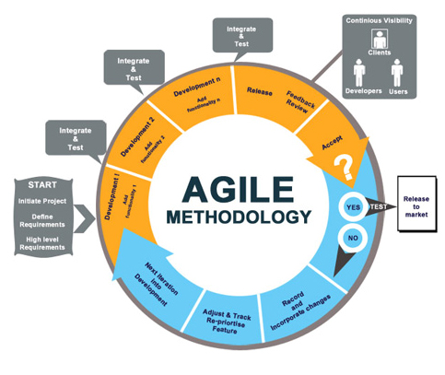*Photo Source:*[http://www.streamlync.com](http://www.streamlync.com/)

The team will have weekly team meetings and accomplish the following:

* Weekly Project Status Report
* Weekly Individual Accomplishment Reports
* Documentation

**Roles and Responsibilities:**

|  |  |  |
| --- | --- | --- |
| Name | Role | Responsibilities |
| Clarence Carillaga | Project Manager | * Manages and leads the team * Monitors project progress and performance |
| Pauline Gabrielle De Ocampo | Database Administrator / Project Analyst | * Documents and analyzes project requirements * Designs database structure * Prepares test plans |
| Phil Harvey Burgos | Developer | * Handles the programming requirements * Manages and designs the system |

## Technical Approach

* **Web Server:** Apache
* **Database Server:** MySQL
* **Programming Languages:** PHP, HTML, CSS, Java
* **Programming Tools:** Yii Framework, Android SDK
* **Design Tools:** Adobe Photoshop
* **Documentation Tools:** Microsoft Office, Pencil Tool, yEd Graph Editor, MySQL Workbench

**USE CASE**

**User Login**

**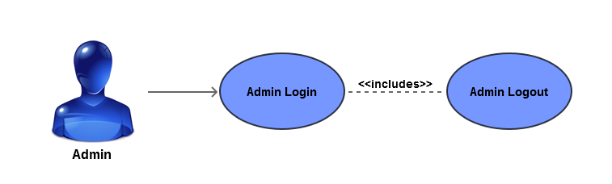**

**User Information**

**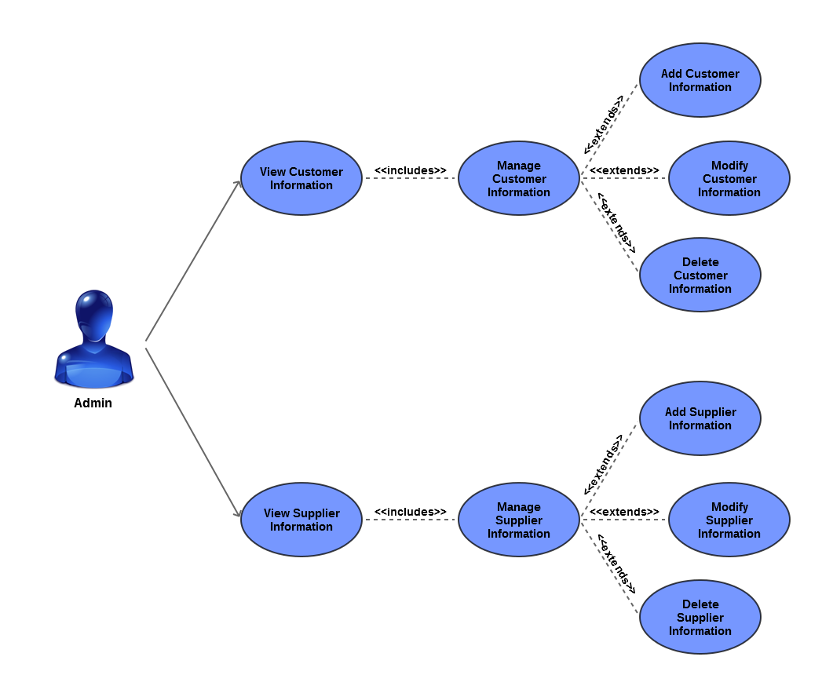**

**Item Records**

**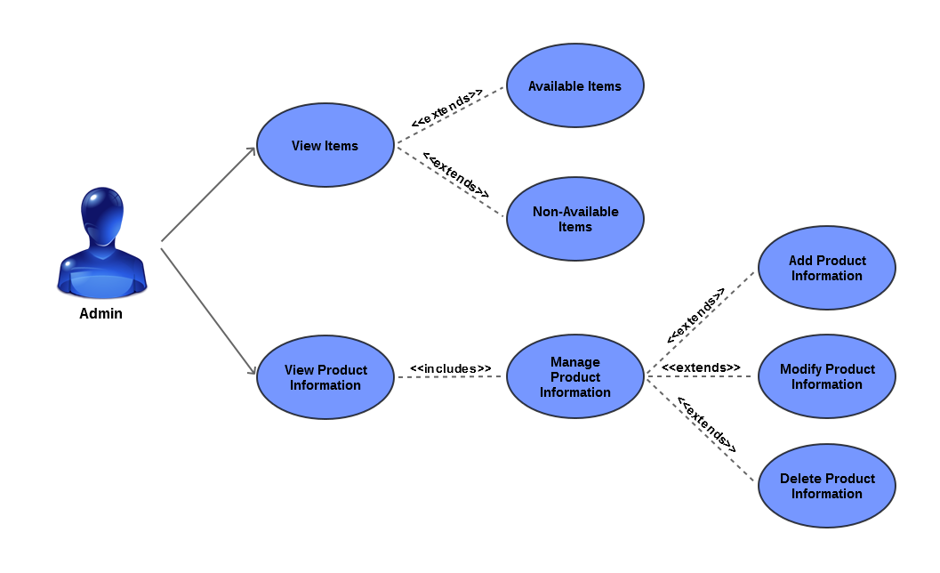**

**Order Records**

**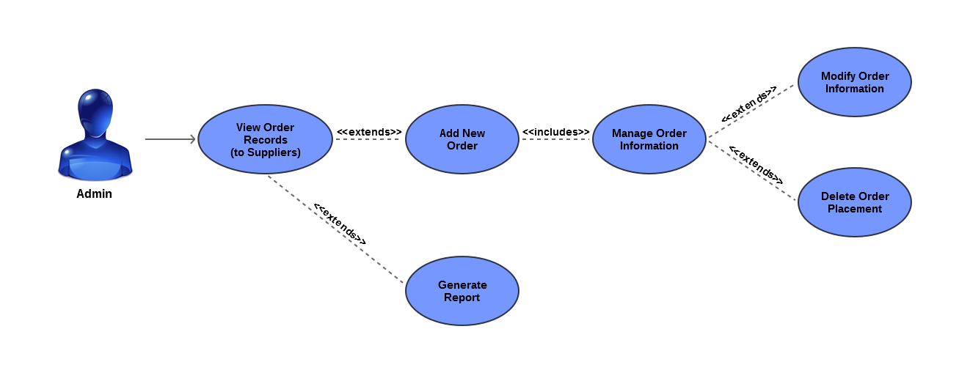**

**Purchase Records**

**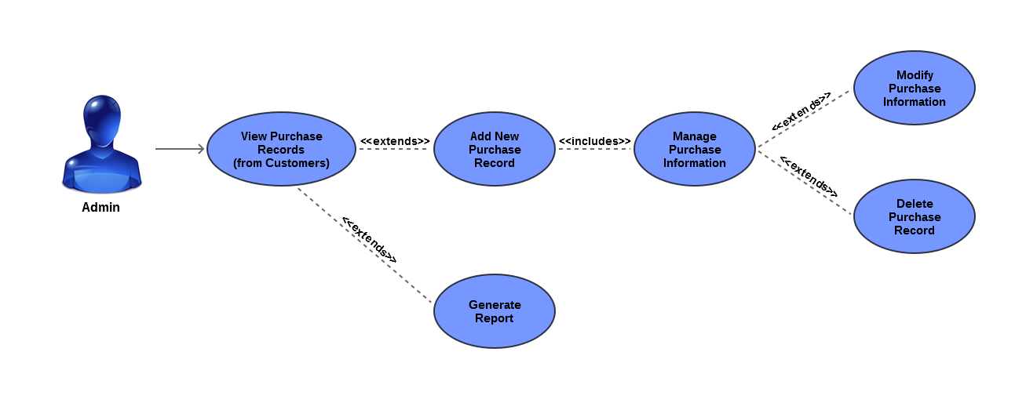**

# Requirements Document

## The Logical Database Description (LDD)

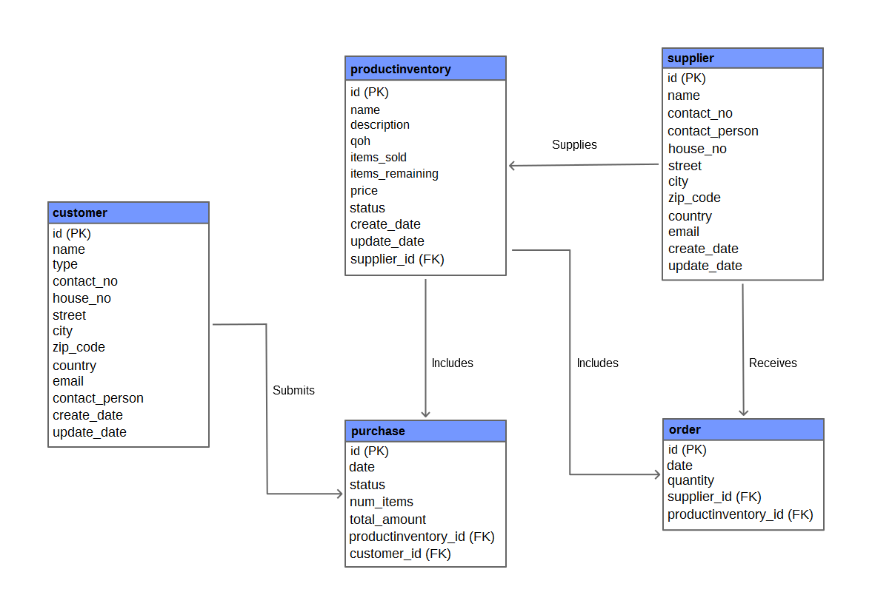

## The Requirements Document (SRD)

**Sales Coordinator (Admin):**

* Can view, add, edit, and delete the product information *(This information consists of item name, item quantity, item price, etc.)*
* Can view, add, edit, and delete the customer information *(This information consists of customer name, customer address, customer contact, etc.)*
* Can view, add, edit, and delete the supplier information *(This information consists of supplier name, supplier address, supplier contact, etc.)*
* Can view, add, edit, and delete the order information *(This information consists of item name, quantity ordered, etc.)*
* Can view, add, edit, and delete the purchase information *(This information consists of item name, customer name, number of items purchased, etc.)*
* Can generate a report based on the annual transactions
* Can generate a report based on the annual orders

## The Requirements Traceability Matrix (RTM)

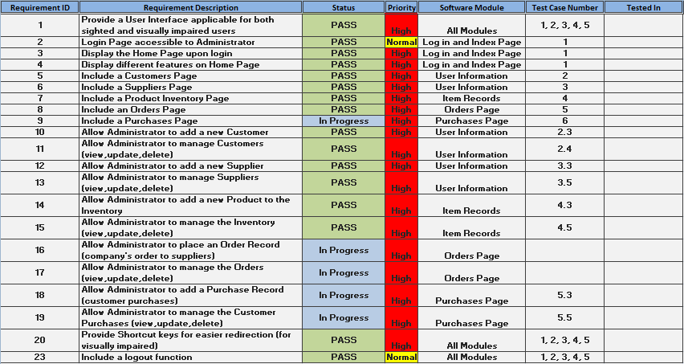

# Design Document

## The Physical Database Description

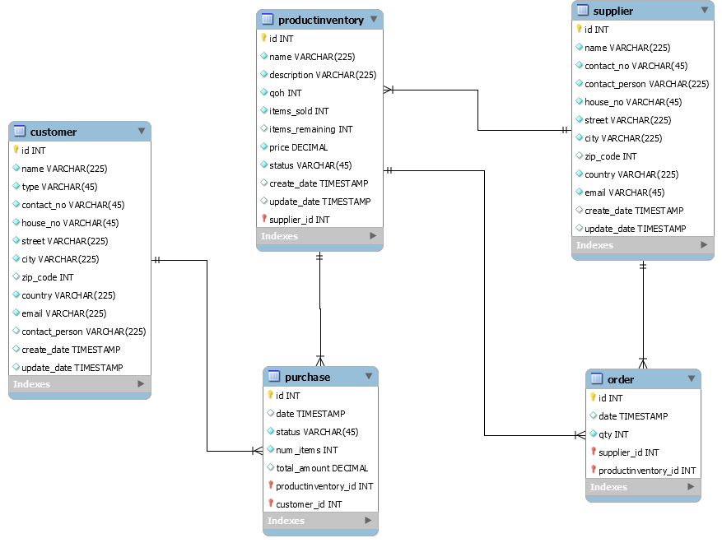

## The Software Design Document

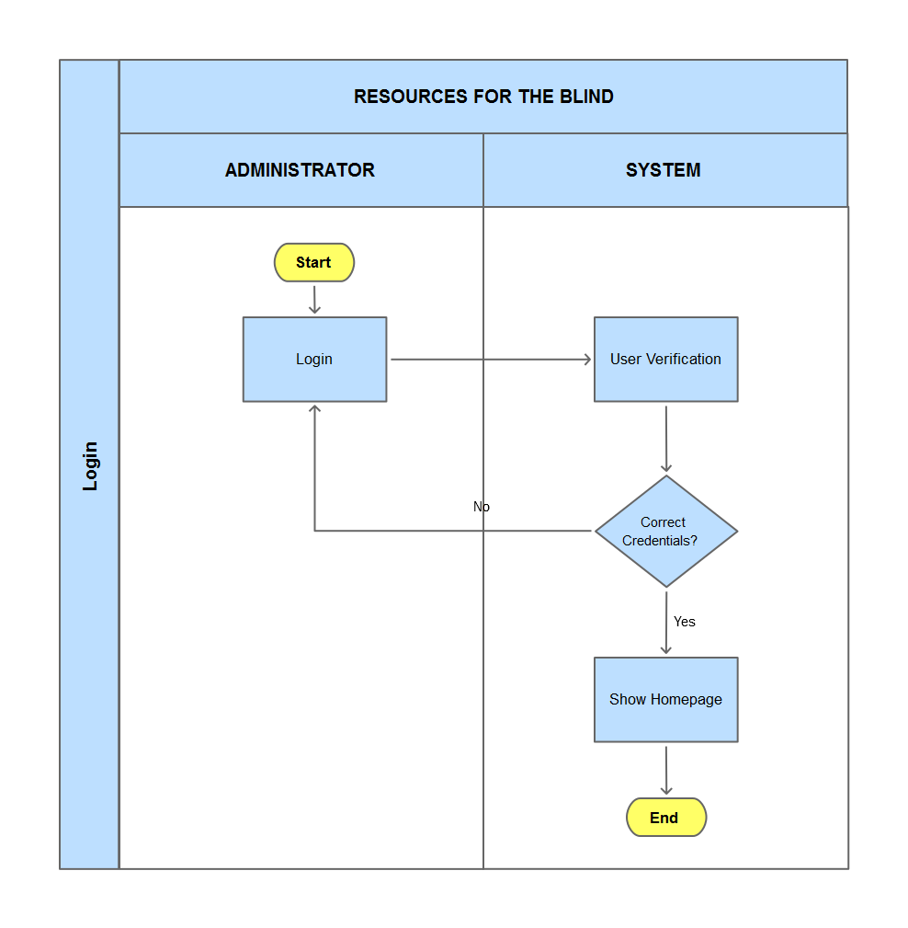

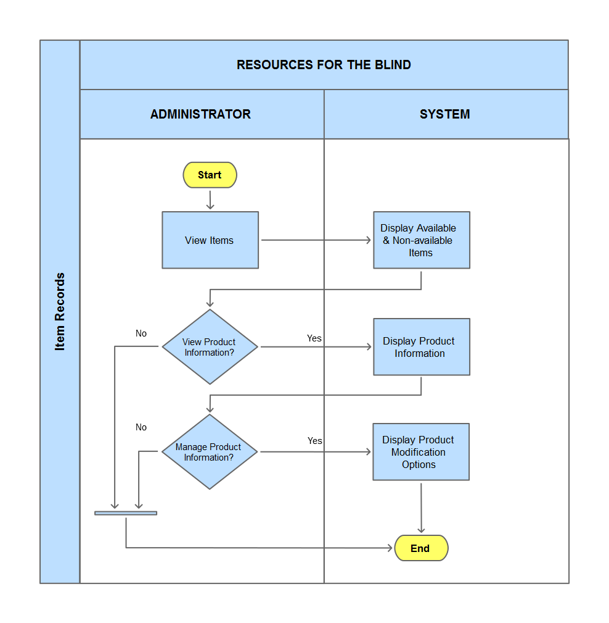

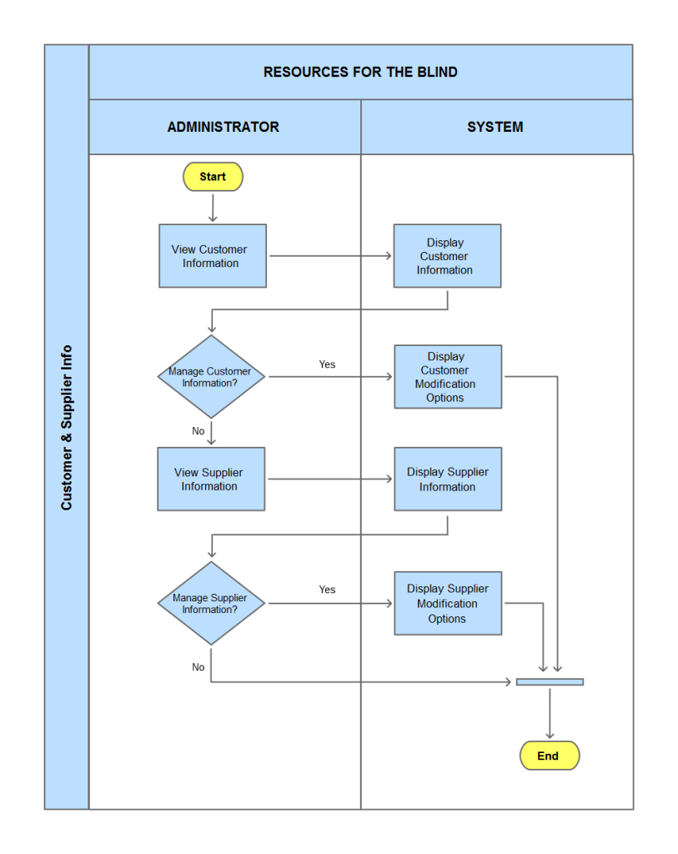

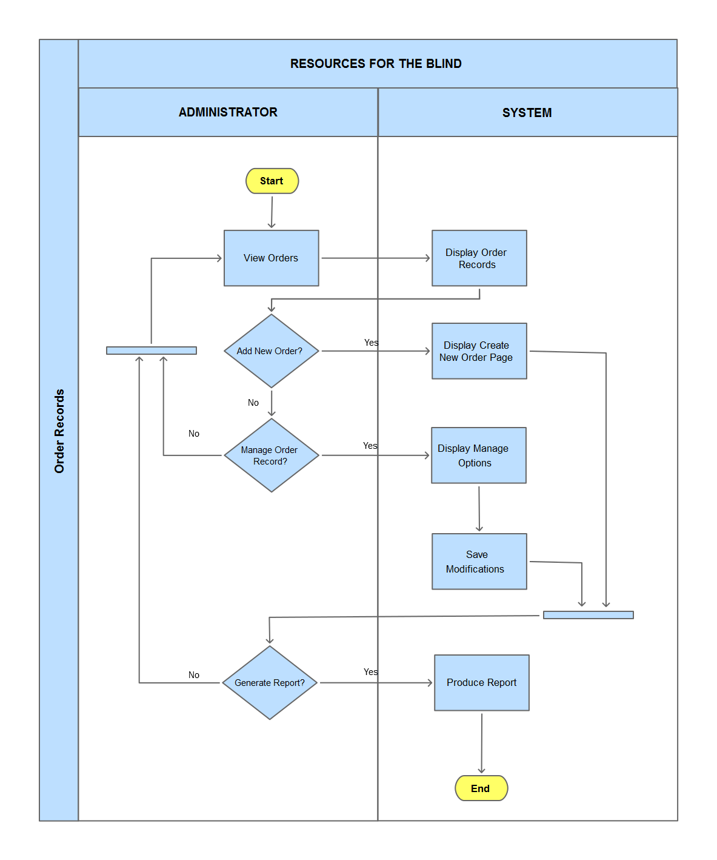

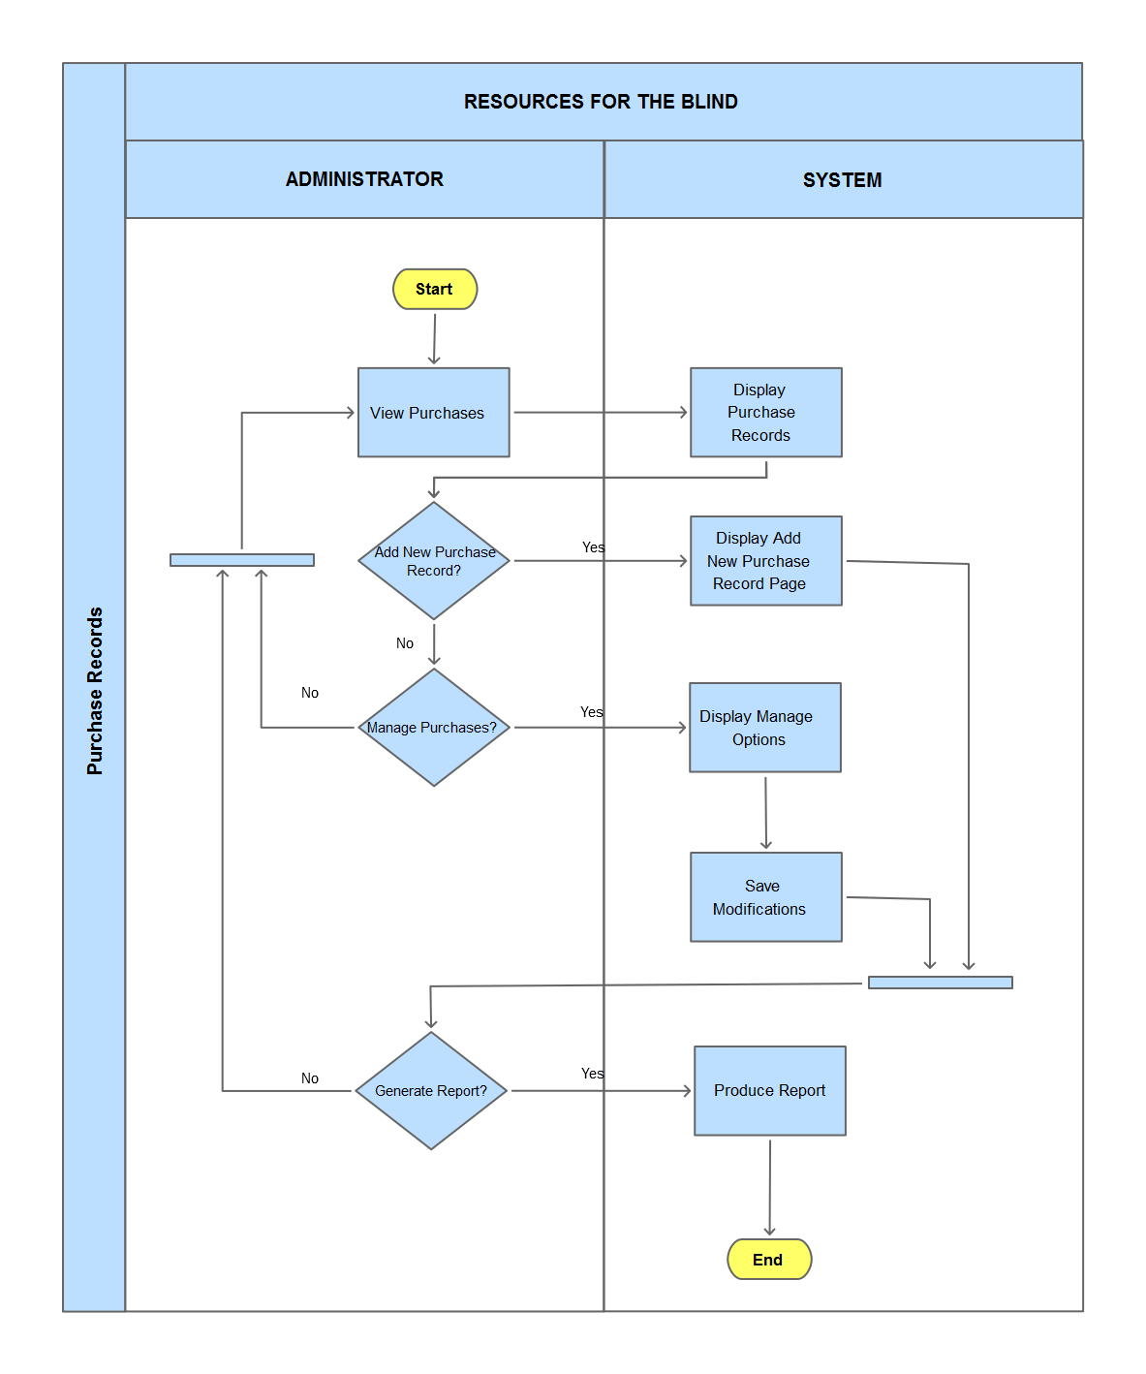

# Online Help

## Data Areas

|  |  |  |
| --- | --- | --- |
| Modules | Features | Functions |
| Product Inventory | * Product Information | * View product information * Add product information * Update product product information * Delete product information |
| User Information | * Customer Information * Contact Person Information * Supplier Information | * View Customer information * Add Customer information * Update Customer information * Delete Customer information * View Contact Person information * Add Contact Person information * Update Contact Person information * Delete Contact Person information * View Supplier information * Add Supplier information * Update Supplier information * Delete Supplier information |
| Transactions | * Report Generation | * Shows annual transactions * Generate annual transactions report |

## Optional Scenarios

**Product Information (Product Inventory)**

* How can I view the whole product information individually, without clicking on the Manage Product Inventory button?
* How can I update the product information individually, without clicking on the Manage Product Inventory button?
* How can I delete the product information individually, without clicking on the Manage Product Inventory button?

*All of these functions can be done easily by clicking on the Product ID link in the table.*

**Customer Information (User Information)**

* How can I view the whole customer information individually, without clicking on the Manage Customers button?
* How can I update the customer information individually, without clicking on the Manage Customers button?
* How can I delete the customer information individually, without clicking on the Manage Customers button?

*All of these functions can be done easily by clicking on the Customer name link in the table.*

**Contact Persons Information (User Information)**

* How can I view the whole contact person information individually, without clicking on the Manage Contact Persons button?
* How can I update the contact person information individually, without clicking on the Manage Contact Persons button?
* How can I delete the contact person information individually, without clicking on the Manage Contact Persons button?

*All of these functions can be done easily by clicking on the Contact Person name link in the table.*

**Supplier Information (User Information)**

* How can I view the whole supplier information individually, without clicking on the Manage Suppliers button?
* How can I update the supplier information individually, without clicking on the Manage Suppliers button?
* How can I delete the supplier information individually, without clicking on the Manage Suppliers button?

*All of these functions can be done easily by clicking on the Supplier name link in the table.*

## Data Dictionary

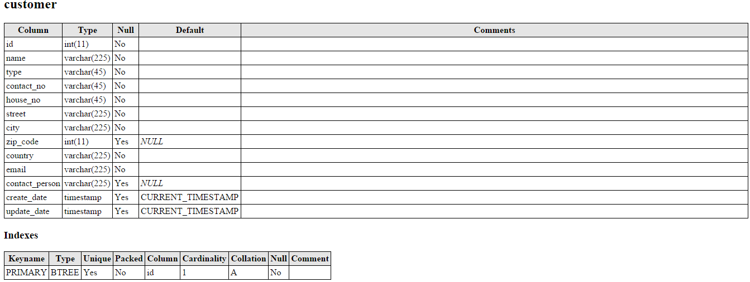

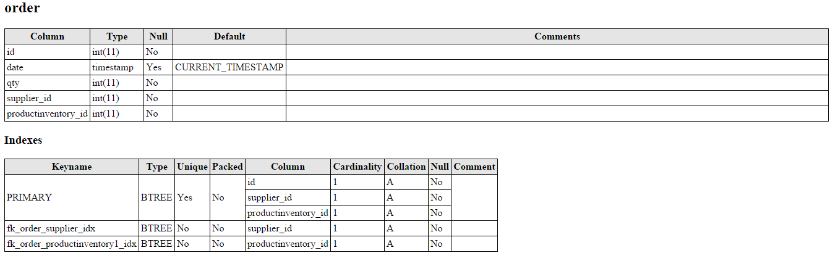

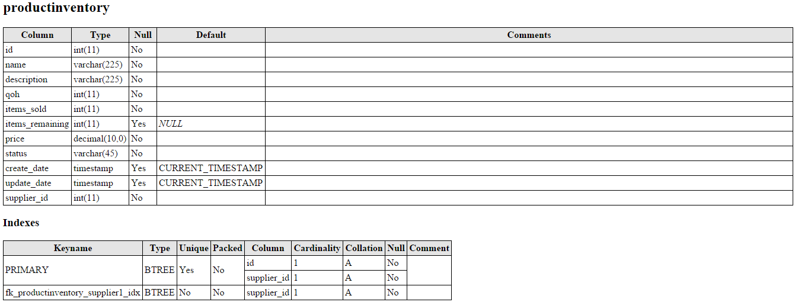

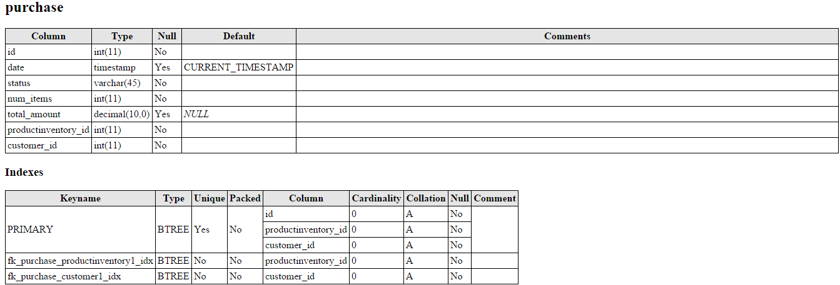

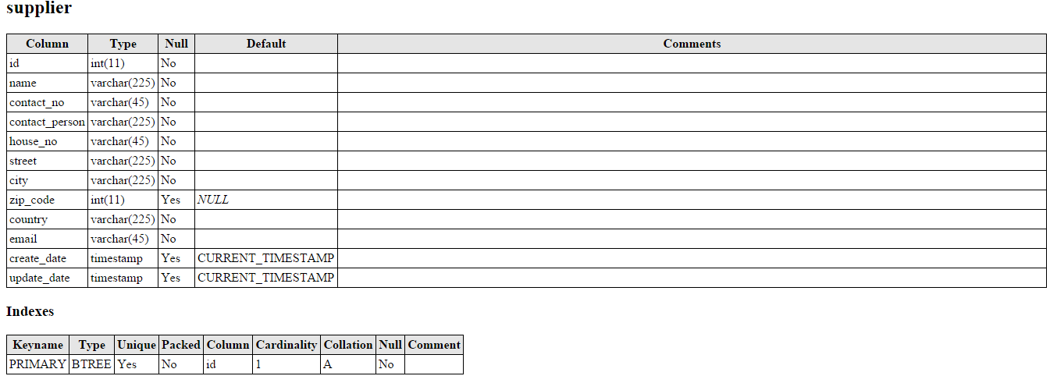

# Implementation Map

## The Implementation Map

**Schedule**

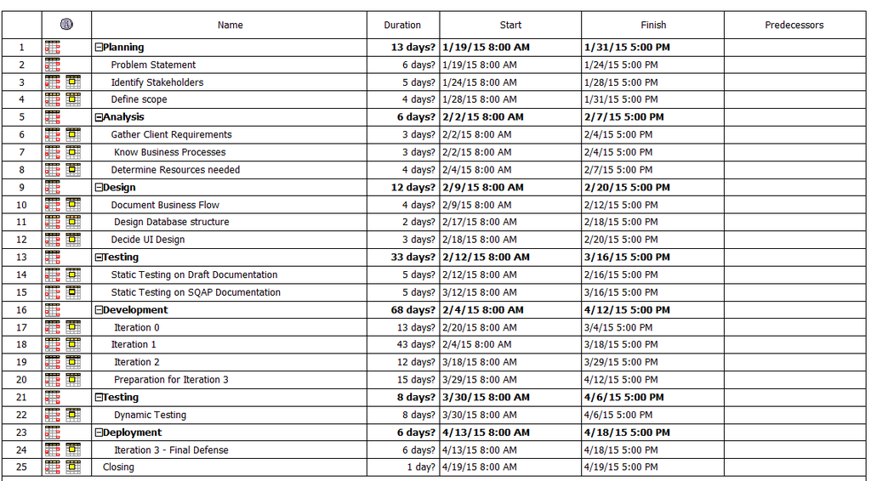

**Gantt Chart**

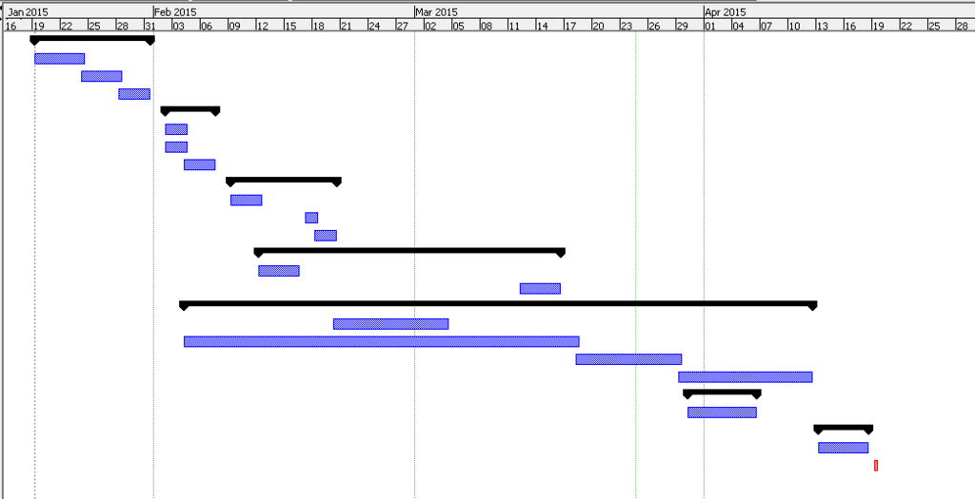

# Test Plan

## The Test Plan

*See attached documents for* [*Test Plan*](https://github.com/joegeneq/apc-softdev-it111-06/blob/63eb15e571ca59386ea8505b29cf08d113e5e975/documentation/quality/Test%20Documents/QUALITY%20RBI%20Test%20Plan.docx)*,* [*Test Cases*](https://github.com/joegeneq/apc-softdev-it111-06/tree/63eb15e571ca59386ea8505b29cf08d113e5e975/documentation/quality/Test%20Documents/Test%20Cases) *&* [*Test Results*](https://github.com/joegeneq/apc-softdev-it111-06/tree/63eb15e571ca59386ea8505b29cf08d113e5e975/documentation/quality/Test%20Documents/Test%20Results) *(Appendices & Hyperlinks).*

# Deployment Plan

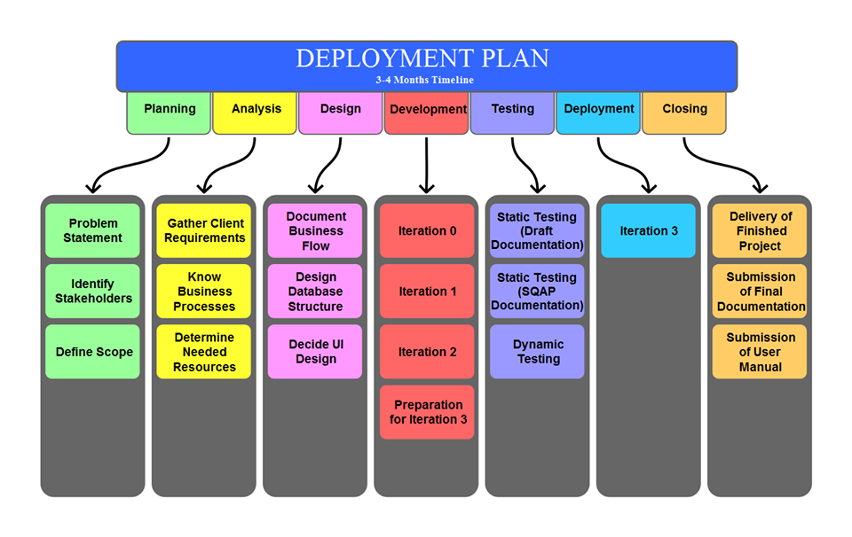

# Acceptance Plan

|  |  |  |  |  |  |
| --- | --- | --- | --- | --- | --- |
| Deliverables | Description | Review Method | Reviewers | Start Date | End Date |
| Software Management Plan | This includes the Vision, Scope, Feasibility and Risk Analysis, Management and Technical Approach of the project | Static Testing | Quality Assurance Group | February 12, 2015 | February 16, 2015 |
| Requirements Document | This includes the Logical Database Description, the Requirements Document and the Requirements Traceability Matrix | Static Testing | Quality Assurance Group | February 12, 2015 | February 16, 2015 |
| Design Document | This includes the Physical Database Description, the Software Design Document and the Requirements Traceability Report | Static Testing | Quality Assurance Group | February 12, 2015 | February 16, 2015 |
| Test Plan | The Test Plan of the project | Static Testing | Quality Assurance Group | March 12, 2015 | March 16, 2015 |
| Test Cases | The Test Cases of the project | Static Testing | Quality Assurance Group | March 12, 2015 | March 16, 2015 |
| RBI - Inventory System | The web application of the Resources for the Blind - Inventory System | Dynamic Testing | Quality Assurance Group | March 30, 2015 | March 30, 2015 |

# Installation & Acceptance

## The Acceptance Configuration Plan

**Installation Plan**

* The Installation of the Inventory System will be done via Hosted and Localhost.
* For Hosted, the Inventory System will be hosted online on a dedicated server.
* For Localhost, all the files and requirements will be set up and configured on (a) specific terminal(s) in order that the Inventory System will be accessed.
* The database must be configured if it will be installed via Localhost.
* All other necessary requirements must also be configured upon installation of the Inventory System.

**Configuration Plan**

* A database wherein all the user information (customers and suppliers), product records, order records and purchases records can be stored.
* The Inventory System can display all records stored (all modules).
* The admin can add, modify, and delete records and its information (all modules).
* The User Interface should be accessible for both sighted and visually-impaired personnel.
* A user manual along with the Online Help of the system should be provided.

# References (Hyperlinks)

[What is Feasibility Study? Types of Feasibility. Explain Feasibility Study Process](http://ecomputernotes.com/software-engineering/feasibilitystudy)

[How To Create A Requirements Traceability Matrix](http://www.google.com.ph/imgres?imgurl=http://img.docstoccdn.com/thumb/orig/34527106.png&imgrefurl=http://loancalculator.social/tag/how-to-create-a-requirements-traceability-matrix-ehow&h=1275&w=1650&tbnid=IGX5bOykNHEA3M:&zoom=1&docid=ZJUS-Y9zJULdXM&ei=vh8iVYzYOJKA8gX_oIHwCA&tbm=isch)

[Implementation Road Map](http://www.inpaspages.com/wp-content/uploads/2013/12/ISO9001-roadmap.gif)

[Deployment Project](http://iqmax.com/uploads/images/content/DeploymentProcess2SHARP.png)

[QUALITY Moodle: Test Plan Outline](http://moodle.apc.edu.ph/pluginfile.php/59959/mod_resource/content/1/Test%20Plan%20Outline.pdf)

[Software Test Plan Template](http://www.epmo.scio.nc.gov/library/docs/TESTPLAN.doc)